**Useful links**

<https://developer.mozilla.org/en-US/docs/Web/API/Window/location>

**Tasks**

You have to create 2 pages:

* Tank preview
* Tank details

Please note, that everything should be created using plain JavaScript functions. You should not edit index.html file at all. You should append your content of the page to the <div id="root"></div>.

Tanks preview

* Should contain headline ‘Most popular tanks’
* Should contain thumbnails of tanks
* Each thumbnail must contain tank image, country flag, tank level, tank name
* On thumbnail click redirect user to page with tank details. (Use window.location.hash and onhashchange event to switch between pages)

Tip: Use browser url hash (eg. path/to/your/project/index.html#page1**)** to differentiate which content to render. Under ‘render’ word means to replace one block with another. For example, by using JavaScript replace thumbnails to tank-details.

// Before click on the tank thumbnail

<div id="root">

<div class="thumbnails">...</div>

</div>

// After click on the tank thumbnail

<div id="root">

<div class="tank-details">...</div>

</div>

Tank details

* At the top of page add headline which contains flag of selected tank, tank name and tank level.
* At the left side of page (below the headline) display full size tank preview image.
* At the right side of page (below the headline) display table with more detailed information about selected tank.
* At the bottom of page, add the link ‘Back to list view’ which will redirect user to the page with Tanks details (the page with thumbnails)

All information regarding the tank and its characteristics must be taken from the file homework_12/tanks.js , which is already included to homework_12/index.html.

Tanks preview page - thumbnails (see Figure 1)

* On thumbnail hover in the list, highlight background in a different color, show the "Click to details" tooltip.
* On the tank flag hover show a tooltip with name of the country.
* On the tank name hover show a tooltip with full name of tank. If the name of tank is to long and doesn’t fit in a single row then cut it and add ellipses.

Tank details page - details (see Figure 2)

* On the flag hover show a tooltip with name of the country.

**FAQ**

Is pixel perfect required? - No

How can I get colors from images? - Find images in a folder homework_12/templates/ and use online tool to pick up a specific color from uploaded image. (<https://html-color-codes.info/colors-from-image/>)

What font is used on the page? - *serif*

**Result preview**

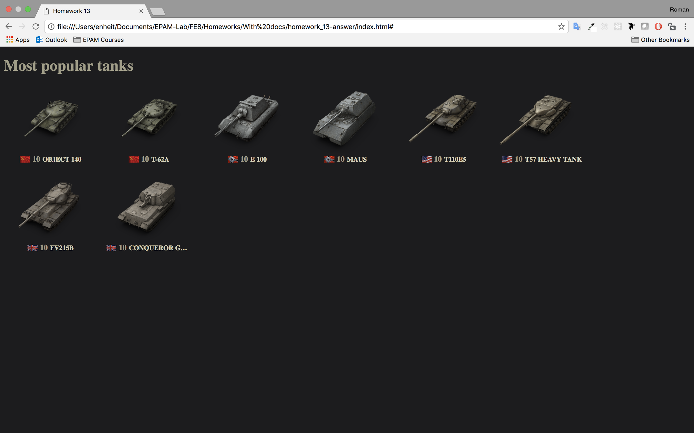

Figure. 1 - The page with a list of tanks

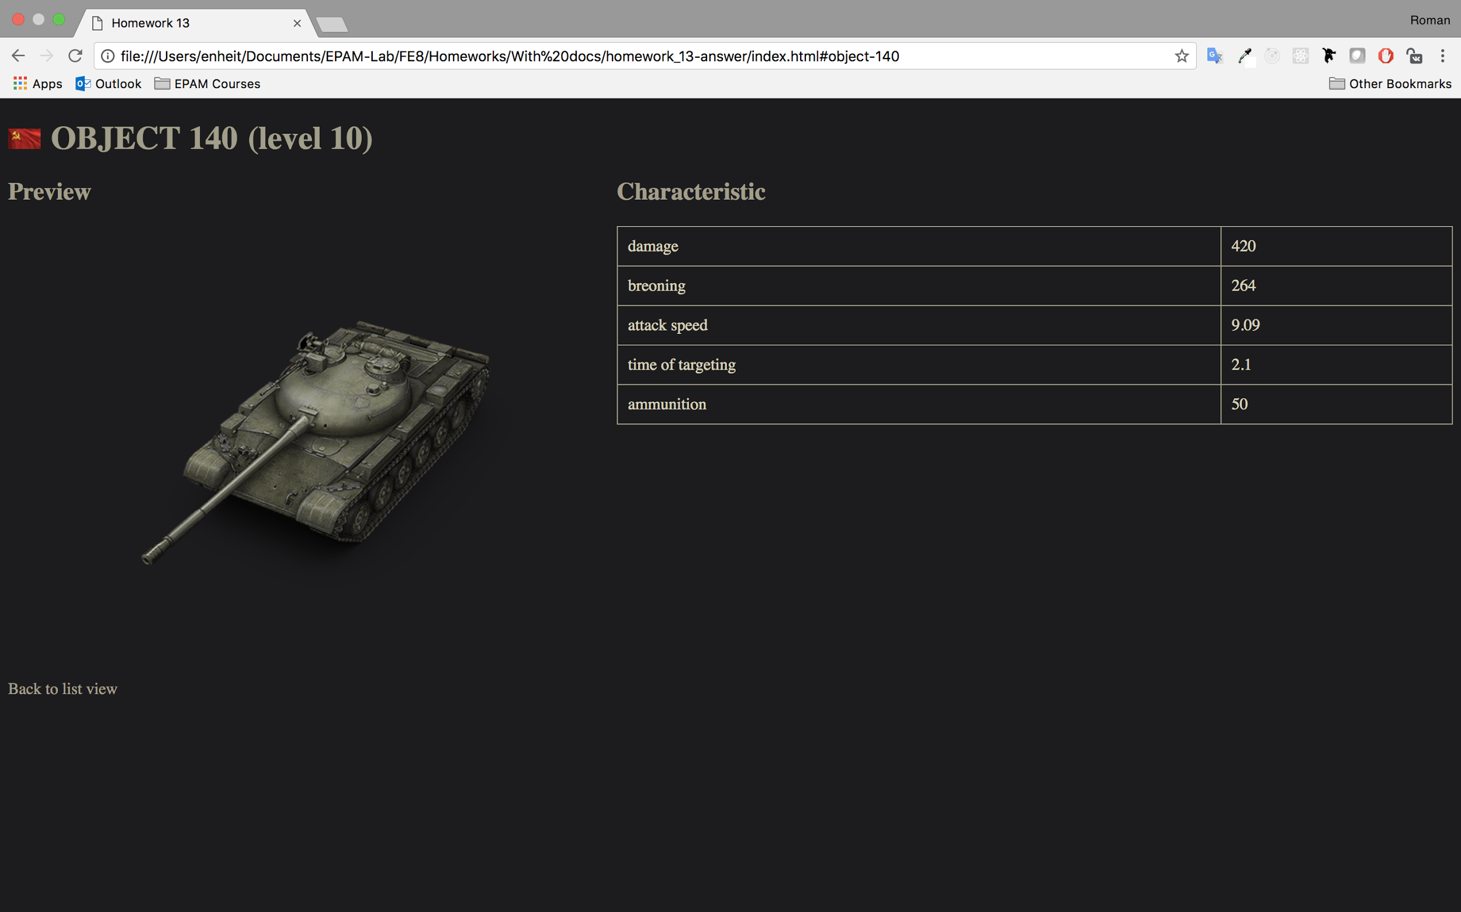

Figure 2 - The page with tank’s details (in this case tank OBJECT 140)

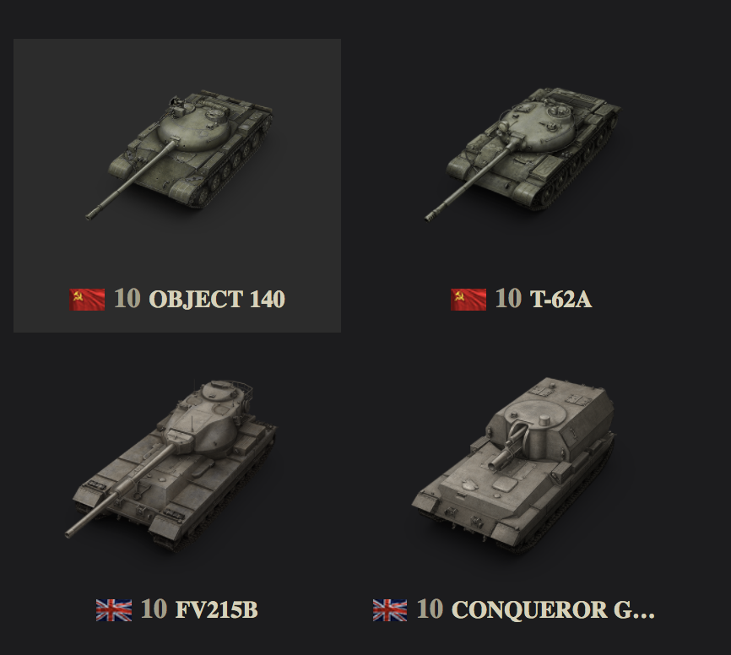

Figure 3 - Tile view when hovering the mouse cursor